

Project Management
12th Project
Dr.Mohamed Ragaie TA.Rahaf Saafan
Group Members:
Mahmoud Samer 231006523
Rawan Atef 231005789
Retaj Ali 231005689
Rokaya Hamdy 231006586
Youssef Karim 231014449
Youssef Mahmoud 231005860
Contents
INTRODUCTION 3
PLANNING BIASES 3
PROJECT CHARTER 3
SCOPE 4
MILESTONES 4
WORK BREAKDOWN STRUCTURE (WBS) 5
DEPENDENCIES 5
ASSUMPTIONS 6
CONSTRAINTS 6
PROJECT PLAN 7
SCHEDULE 7
PHASES 8
TASKS 8
RESOURCES 8
MS PROJECT PLAN & GANTT CHART 9
PROJECT BUDGET 11
PROJECT BUDGET & COST ESTIMATION 11
QUALITY MANAGEMENT 12
QUALITY METRICS 12
QUALITY REPORTS 12
HUMAN RESOURCES MANAGEMENT 13
COMMUNICATION MANAGEMENT 13
RISK MANAGEMENT 14
RISK MANAGEMENT TABLE 14

INTRODUCTION
Smart Bite is an AI-driven recipe maker created to transform ordinary kitchen ingredients into practical, healthy meals. By combining a camera-based ingredient scanner with an intelligent recipe engine, it solves the everyday question: “What should I cook?”, Instead of guiding users on what to buy or offering professional dietary plans, Smart Bite focuses on a clear purpose of connecting the ingredients people already have to meals they can make.
This app is designed for students, busy professionals, families, and anyone short on time or cooking experience, Smart Bite reduces food waste, saves money, encourages healthier eating habits and simplifies decision-making by instantly turning available items into cost-effective, nutritious recipes.

PLANNING BIASES

PROJECT CHARTER
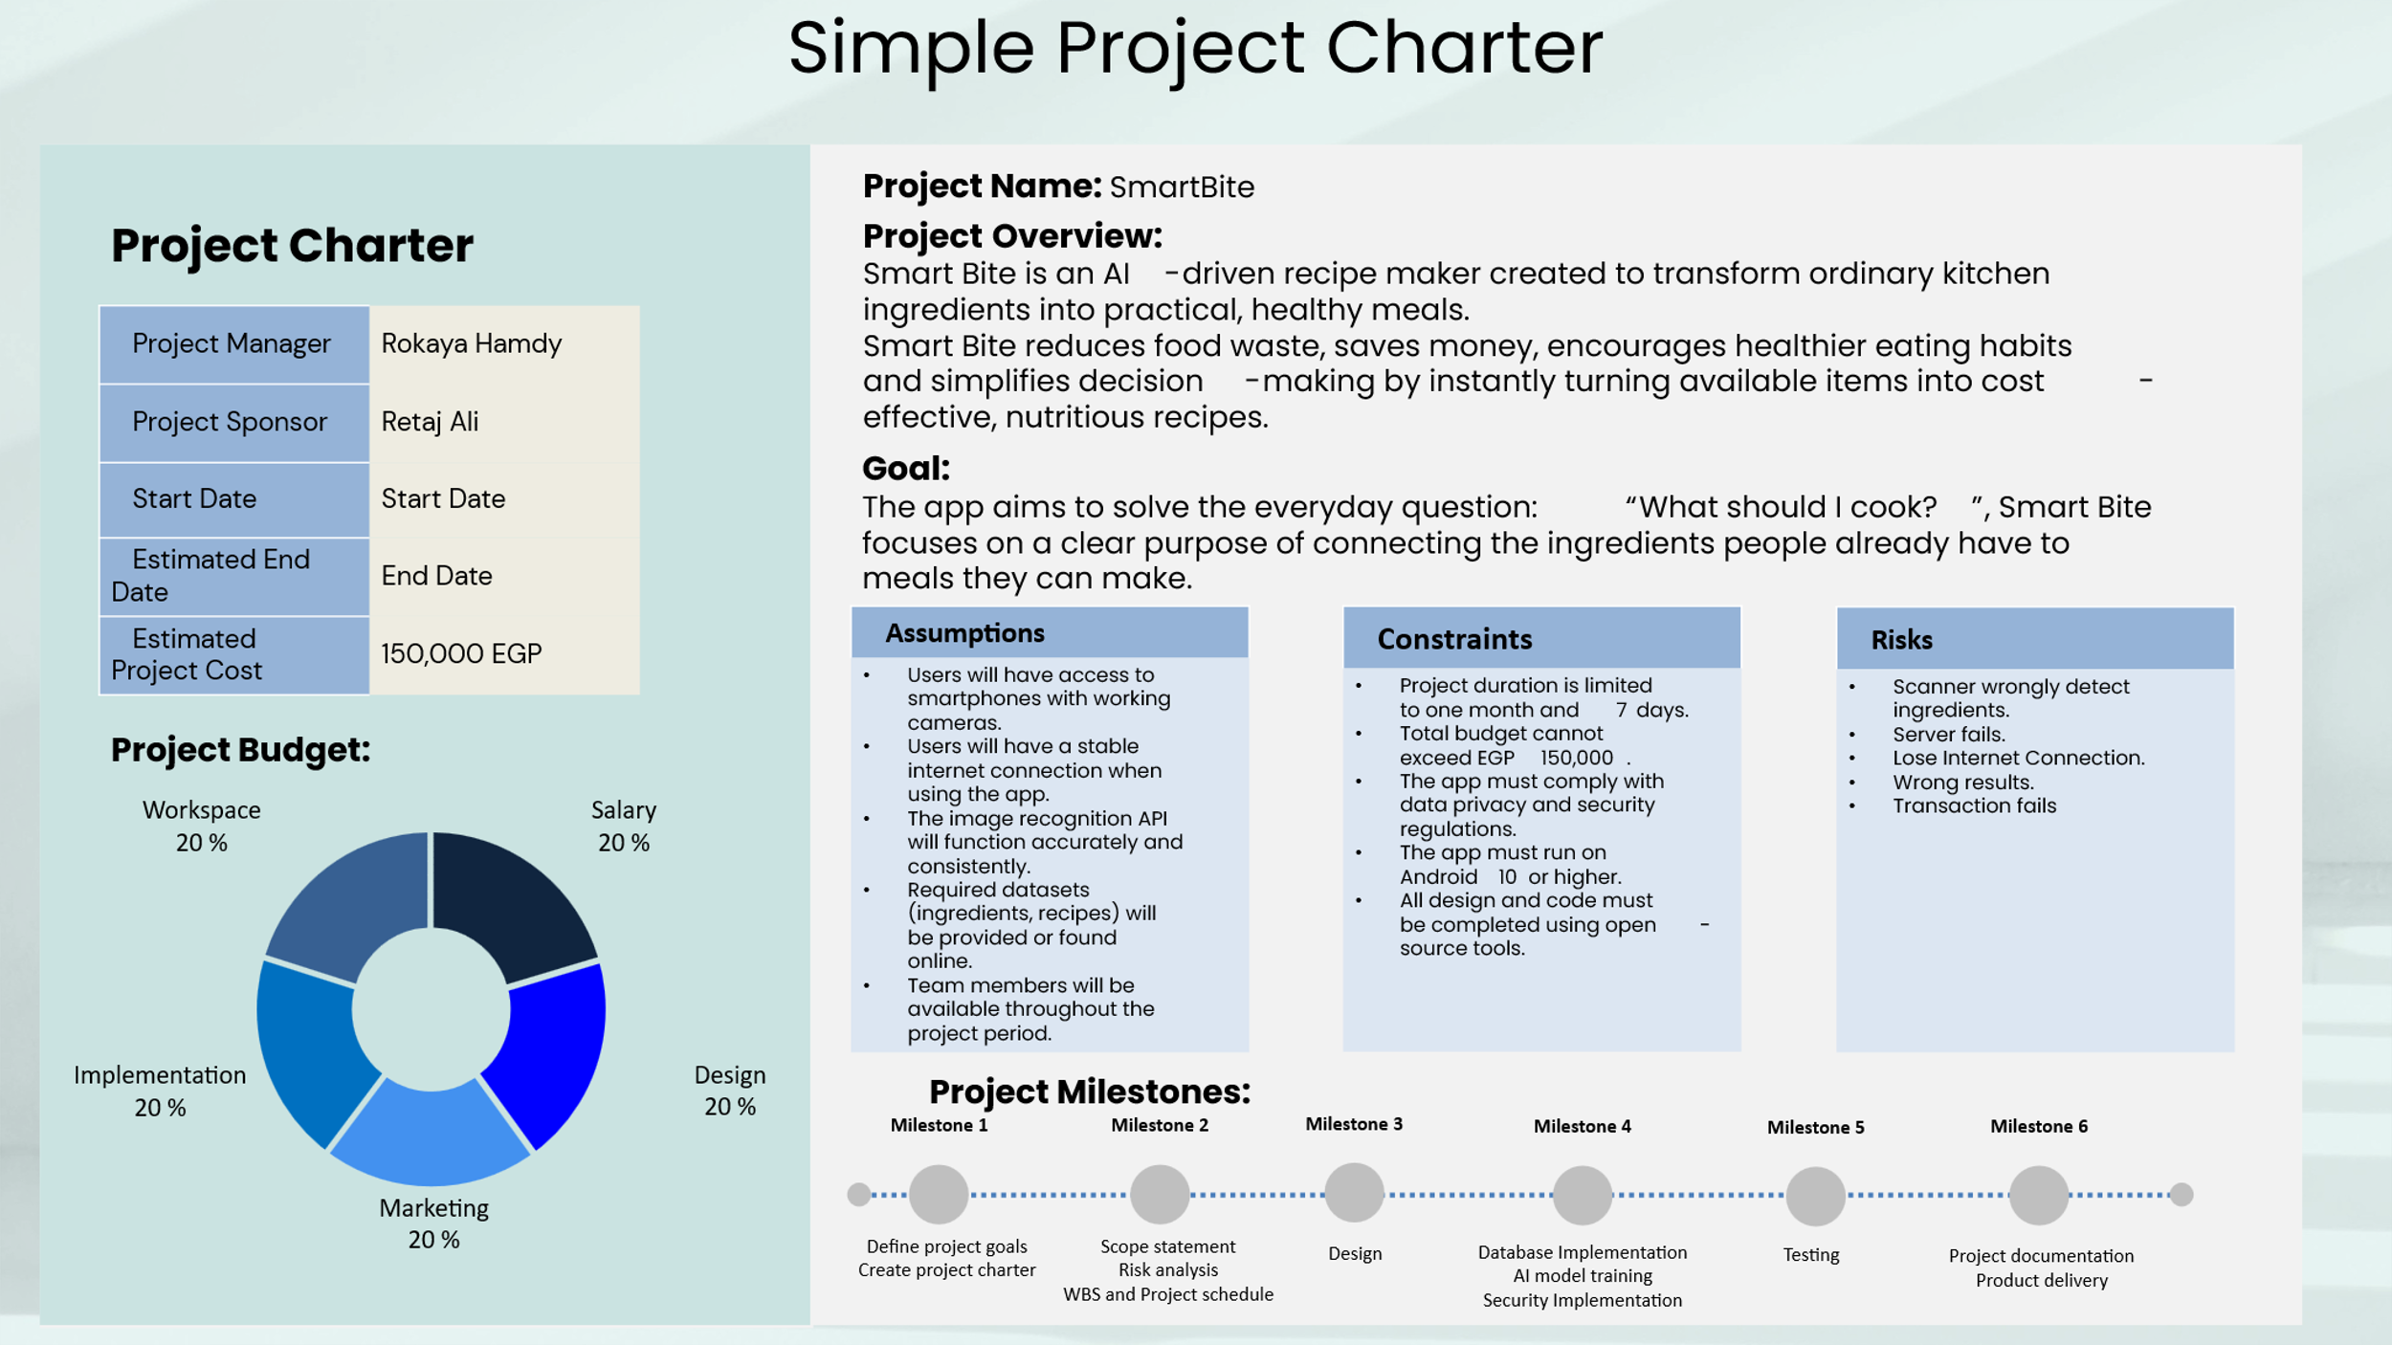

SCOPE
Smart Bite is not designed to replace the grocery store, meal delivery services or professional nutrition counselling. Instead, its role is focused & clear: to help users make the most of what they already have at home. The product directly addresses common problems like wasted groceries, limited cooking skills and lack of time to plan meals.
The project is limited to converting the user’s existing ingredients into ready-to-cook recipes. It does not include external integrations such as online stores or health tracking services. These boundaries ensure that Smart Bite stays focused on its core purpose; bridging the gap between a cluttered fridge and a finished dish — while preventing scope creep.

MILESTONES
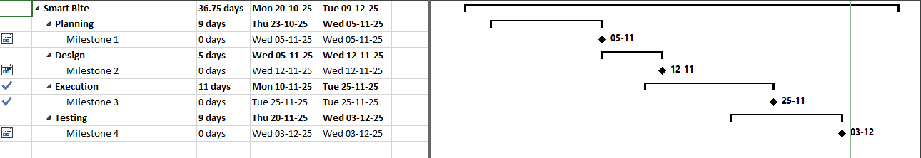

WORK BREAKDOWN STRUCTURE (WBS)
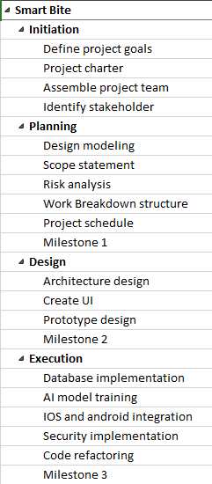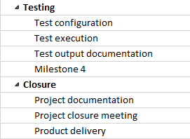

DEPENDENCIES
- Recipe generation feature depends on the ingredient recognition model being trained and tested.
- UI design depends on finalizing the list of core features.
- App launch depends on approval from the Google Play Store and App store.
- Ingredient detection accuracy depends on the quality of the photo scanner.

ASSUMPTIONS
- Users will have access to smartphones with working cameras.
- Users will have a stable internet connection when using the app.
- The image recognition API will function accurately and consistently.
- Required datasets (ingredients, recipes) will be provided or found online.
- Team members will be available throughout the project period.

CONSTRAINTS
- Project duration is limited to one month and 7 days.
- Total budget cannot exceed EGP 150,000.
- The app must comply with data privacy and security regulations.
- The app must run on Android 10 or higher.
- All design and code must be completed using open-source tools.

PROJECT PLAN

SCHEDULE
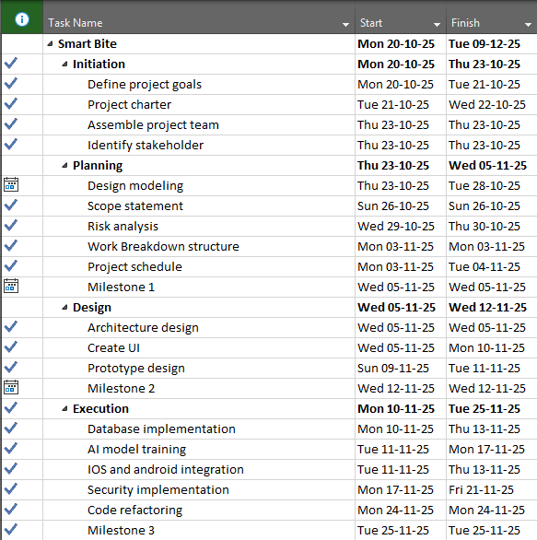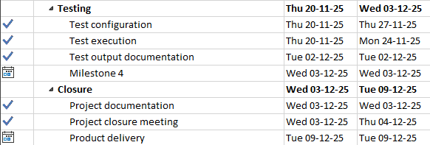

PHASES
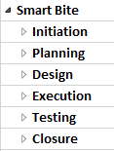

TASKS
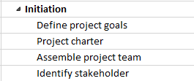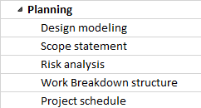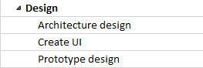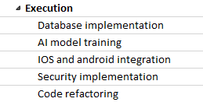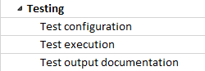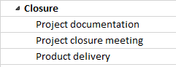

RESOURCES
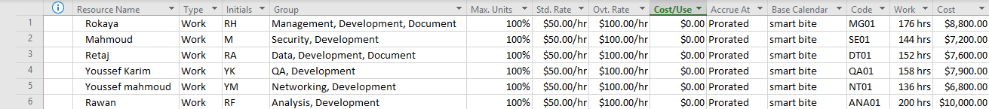

MS PROJECT PLAN & GANTT CHART
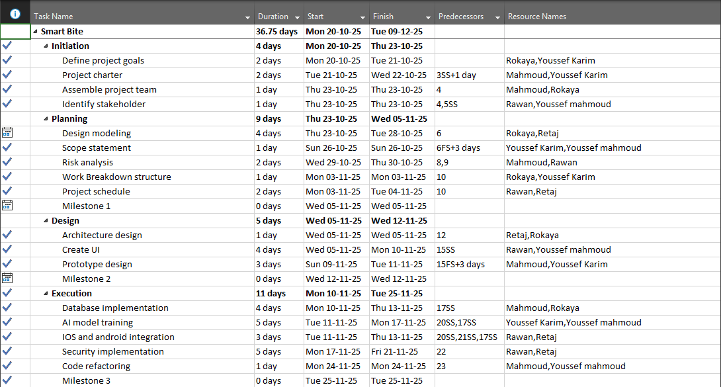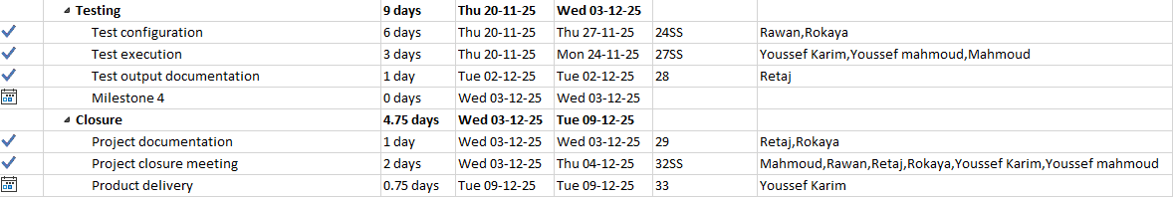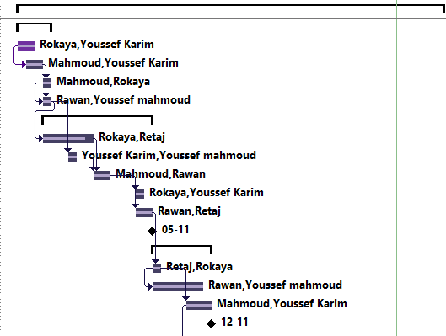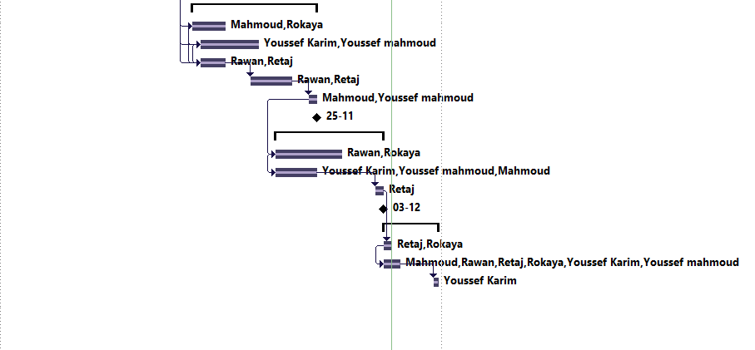

PROJECT BUDGET

PROJECT BUDGET & COST ESTIMATION
Id | Resource ID | Item Name | Price per Item | Price per Hour | Estimated Total Items Needed | Estimated Total Working Hours | Estimated Cost per Total Items | Estimation Calculation Method Used
PB1 | RES1P | Jira | 0$ | 0$ | 1 | 80 | 0$ | One Point Estimating
PB2 | RES2P | Excel | 0$ | 0$ | 1 | 40 | 0$ | One Point Estimating
PB3 | RES3P | Microsoft project | 0$ | 0$ | 1 | 120 | 0$ | One Point Estimating
PB4 | RES4D | Figma | 16$ | 0$ | 1 | 40 | 16$ | One Point Estimating
PB5 | RES5D | Android Studio | 0$ | 0$ | 1 | 100 | 0$ | One Point Estimating
PB6 | RES6E | FireBase | 300$ | 0$ | 1 | 60 | 300$ | Parametric Estimating
PB7 | RES7E | Vision API | 1.50$ | 0$ | 2 | 50 | 3$ | Parametric Estimating

Estimated Total Cost: 300$ + 16$ + 3$ = 319$

QUALITY MANAGEMENT

QUALITY METRICS
Id | Name | Measurement type | Result Range | Tolerance (accepted level) | Measurement Tools | Tools Accuracy
QM-1 | Recipe Generation API Response Time | Time (milliseconds) | 0 - 5000 ms | < 2000 ms | Automated API testing tools | 90%
QM-2 | AI Ingredient Detection Accuracy | Percentage (%) | 0 - 100% | > 90% | Labeled test dataset of images, validation script | 93%
QM-3 | User Satisfaction Score (USS) | Score (1-5) | 1 - 5 | > 4.0 | In-app surveys, feedback forms | 80%

Id | Name | Quality Metric ID | Report maker | Results | Acceptance
QR-1 | Weekly Performance Check | QM-1  QM-2 | QA-1 (Youssef) | (Avg: 1850ms)  (Accuracy: 92%) | Accepted
QR-2 | Beta-Tester Feedback | QM-3 | PM-1 (Rokaya) | (Avg Score: 4.2/5) | Accepted
QR-3 | Pre-Load Performance Spike | QM-1 | SYS-1 (Automated) | (Avg: 3100ms) | Rejected

QUALITY REPORTS

HUMAN RESOURCES MANAGEMENT

COMMUNICATION MANAGEMENT
id | Name | Contacts | Preferred  contact | Preferred time to contact | photo
CON-1 | Mahmoud Samer | Mobile:  +20 123 456 7890  Email:  MS@gmail.com  Work:  12 block 1158 Sheraton. | Phone | Weekends | 
CON-2 | Rawan Atef | Mobile:  +20 115 201 9000  Email:  Roro@gmail.com  Work:  12 block 1158 Sheraton. | Email | Tuesday – Wednesday  9 pm – 11pm | 
CON-3 | Retaj Ali | Mobile:  +20 111 438 2192  Email:  Reta@gmail.com  Work:  12 block 1158 Sheraton | Phone | Sunday – Monday  5 pm – 7pm | 
CON-4 | Rokaya Hamdy | Mobile:  +20 115 729 7353  Email:  Roky@gmail.com  Work:  12 block 1158 Sheraton. | Email | Working Hours | 
CON-5 | Youssef Karim | Mobile:  +20 110 105 0500  Email:  Kimo@gmail.com  Work:  12 block 1158 Sheraton. | Phone | Working Hours | 
CON-6 | Youssef Mahmoud | Mobile:  +20 122 405 7303  Email:  Natsu@gmail.com  Work:  12 block 1158 Sheraton. | Email | Working Hours | 

RISK MANAGEMENT

RISK MANAGEMENT TABLE
id | Risk Name | Description | Type | Category | Response | Risk Exposure
RSK-1 | AI Model Inaccuracy | The core AI fails to correctly identify ingredients or generate poor-quality recipes, leading to user frustration. | Ambiguity | Internal | Implement a manual ingredient input option. Continuously retrain the model with new data. | P = 4  I = 9  Score = 36
RSK-2 | Third-Party API Failure | The external image recognition API or payment gateway becomes unavailable, slow, or changes its pricing model. | Event | External | Develop a fallback in-house recognition model. Integrate a secondary payment provider. | P = 2  I = 8  Score = 16
RSK-3 | Project Budget Overrun | Unexpected costs cause the project to exceed the budget. | Ambiguity | Internal | Implement strict budget tracking. Defer non-essential features to a "Phase 2" release. | P = 3  I = 7  Score = 21
RSK-4 | App Store Rejection | The application is rejected by Google Play Store or Apple App Store due to policy violations or security flaws. | Event | External | Thoroughly review store guidelines. Conduct extensive QA testing on various devices before submission. | P = 2  I = 9  Score = 18
RSK-5 | Low User Adoption | The app fails to attract a sufficient user base after launch due to poor marketing or strong competition. | Ambiguity | External | Implement a pre-launch marketing campaign. Offer a free trial period and gather user feedback aggressively for improvement. | P = 4  I = 10  Score = 40

